
GIS Library Tutorials – Introduction to ArcGIS Online - 8

Importing a csv file and running an attribute table query
Firstly, we’ll have a look at the data we are using – this is in the csv file Primary Schools 2020-2021 which is available from: https://www.gov.ie/en/collection/primary-schools/ (section on schools in Fingal Local Authority has been extracted and saved)
This data has addresses and Eircodes, but no x,y coordinates such as ITM or IG or LAT / LONG
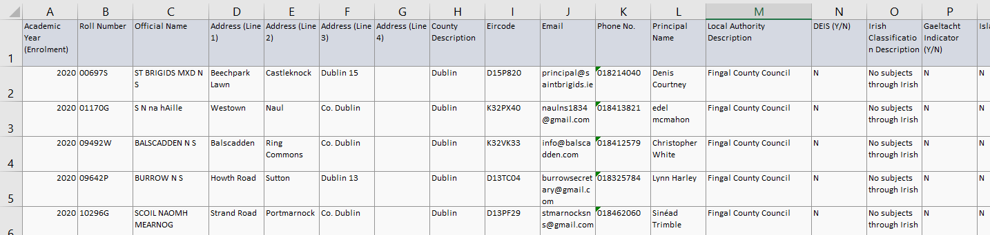

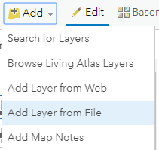
Left click on the Add button
From the menu which opens left click on Add Layer from File

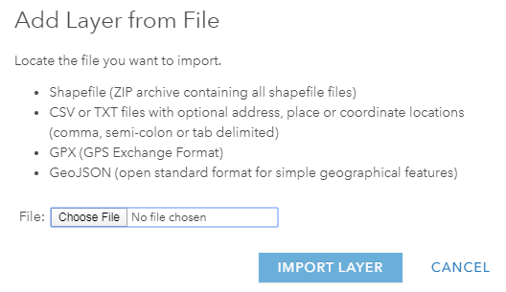
Left click on Choose File and navigate to your folder where the Fingal Primary Schools csv file is saved

Left click on the Fingal Primary Schools file and when it is highlighted left click on Open
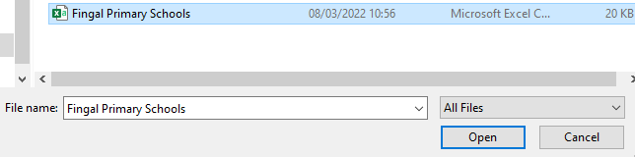
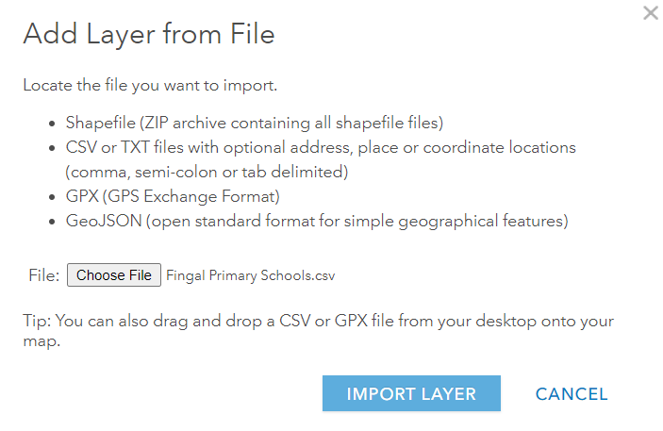
The Fingal Primary Schools csv file is now ready to import
Left click on IMPORT LAYER

There are no coordinates in our Dublin Primary schools file, so left click in the radio button for Addresses or Places – we will use this option to place our schools on the map
In: For this field ensure Ireland is selected – if not use pull-down menu to find Ireland and select it
The items in the Field Name column are taken from the Fingal CSV spreadsheet – however these not used as Location Fields by ArcGIS Online
Scroll down to Eircode.

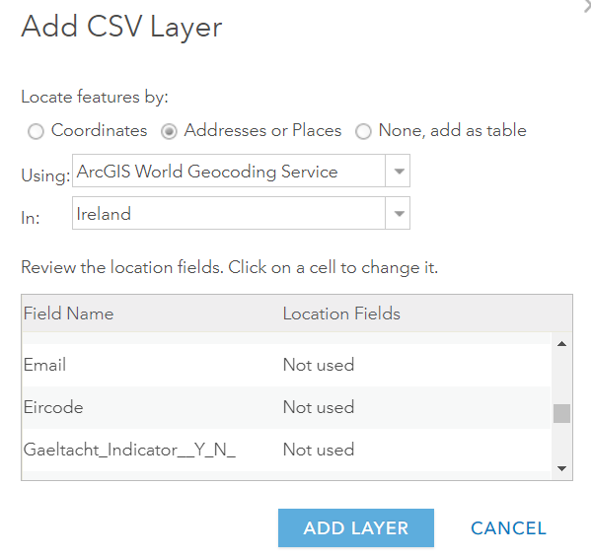

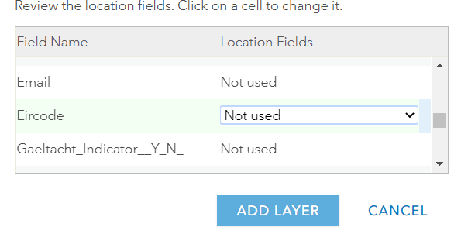 We will tell ArcGIS Online to use our Eircode field to map the schools on the map. We will match Eircode to the correct Location field type.
Next to Eircode left click on the text Not used – then click on the pull-down arrow

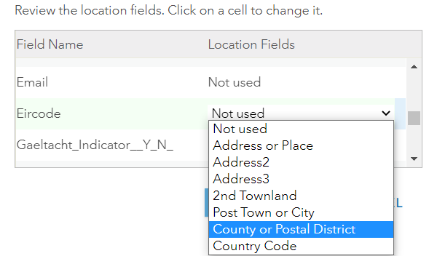
From the options given left click on County or Postal District

Left click on Add Layer


The display you see may be different to this, but if you click on Details and Content you should then see the primary schools represented as black dots on the map
Save the map again 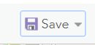

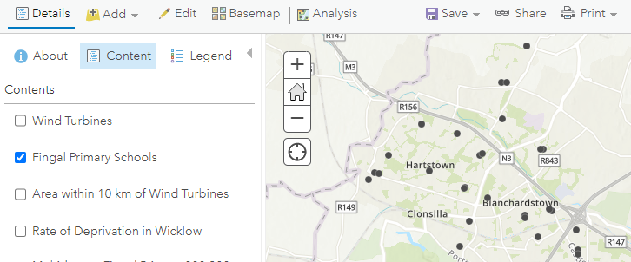

This is an example of Point data – with point data you can create Heat Maps. These show, as the name suggests, where the most intense concentration of data is located – a colour range is used to depict this concentration / heat.
Hover over the layer for Fingal Primary Schools and left click on the Style icon
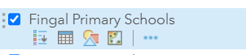

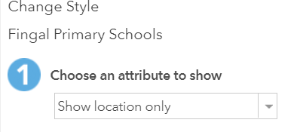
At the arrow under Choose an attribute to show leave it at Show location only

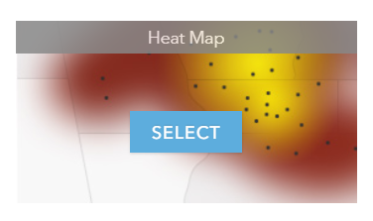
Left click on SELECT in Heat Map
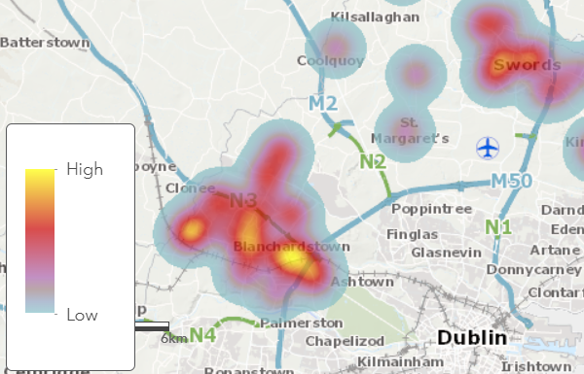
As explained by the legend, the bright yellow colour represents the areas with the greatest concentration of schools
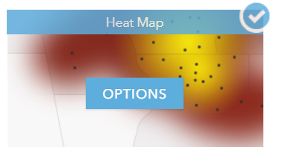
Left click again on OPTIONS

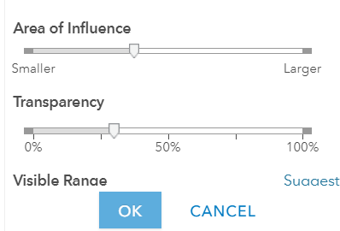
To make the colours stronger, left click on the tab on the Transparency slider and move it to 0%
Left click on OK
On the next screen left click on DONE

Creating a query with attribute data

Run a query to find Primary Schools in Fingal which are Multi Denominational with female pupil numbers of between 200 – 300
Any of the data in the csv file can be queried to find a particular set of information / results

In the Fingal Primary Schools layer left click on the Analysis icon
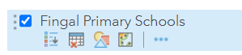
When the menu opens left click on Find Locations
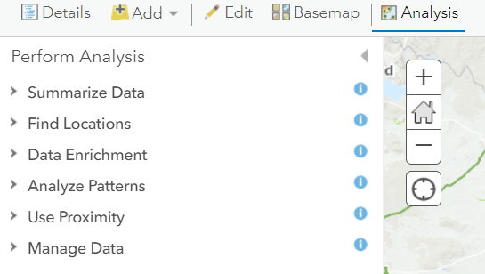

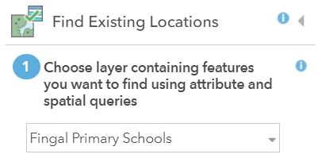
Left click on Find Existing Locations
The Layer you wish to run the query on Fingal Primary Schools is shown
(if you were running a search on a different layer you would scroll via the down arrow to find & select it)

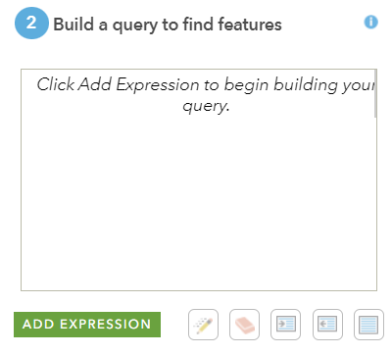
Left click on ADD EXPRESSION to start creating your query

The template for the ADD EXPRESSION query will open
Left click on the Down Arrow to find and select the first field you wish to start your query with, in this example we will start with the Ethos Description field
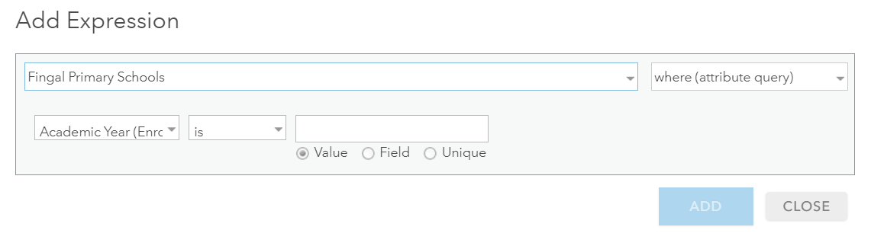In the second field leave the word ‘is’ as the default
Left click on Unique, then left click on the down arrow
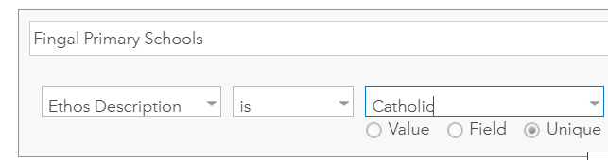

When the word Multi Denominational appears left click on it. Then left click on ADD

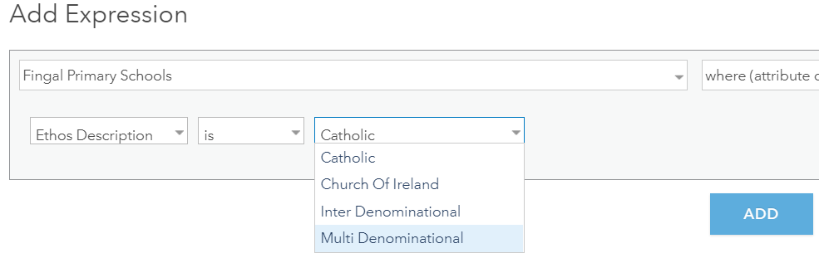

This brings you back to the main box where your query will appear, next, left click again on ADD EXPRESSSION

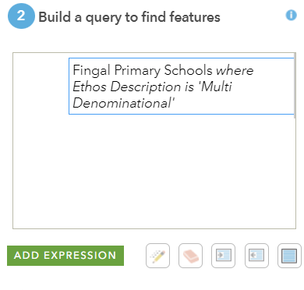
Scroll down and left click on FEMALE, in the next field scroll down and left click on is between
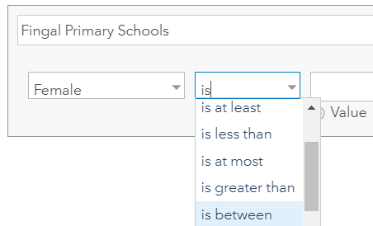
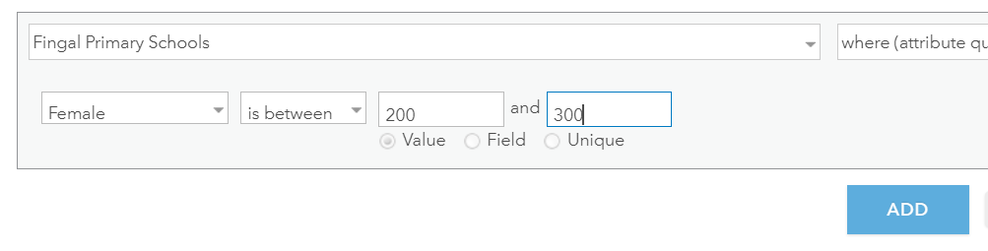
Enter the numbers 200 and 300 into the two fields which open (these will automatically default to Value fields), and left click on ADD

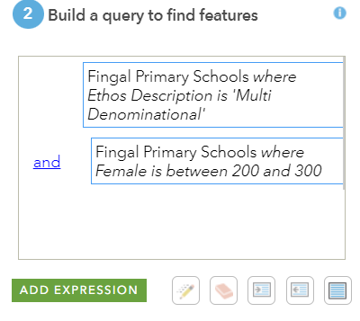
Your query is now ready to run
Left click in the Result layer name to change it to something more relevant, e.g., Multidenom Fingal Primary 200 -300 Girls
Make sure Use current map extent is ticked and that your map shows the whole area of Fingal
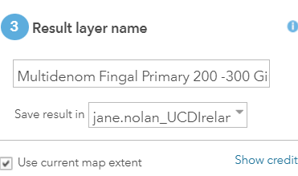

Left click on RUN ANALYSIS


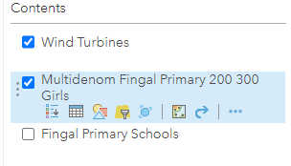
Left click in the checkbox next to Fingal Primary Schools to remove the tick – this will hide all of the other buildings / structures which have been represented as a heat map

The new layer Multidenom Fingal Fingal Primary 200 300 Girls should now appear on your map within a minute or two. In this example they are symbolised by blue dots on the map

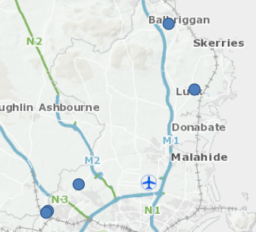

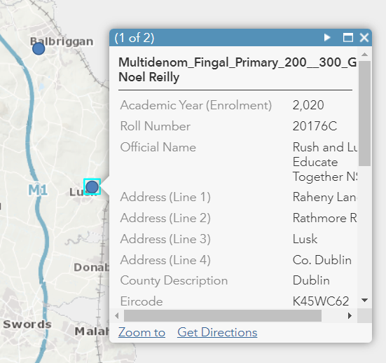
Left click on any blue dot to read information about that school

Left click on Save

